The Rotary Clubs of Abingdon & Abingdon Vesper

Celebrate 100 years of Rotary

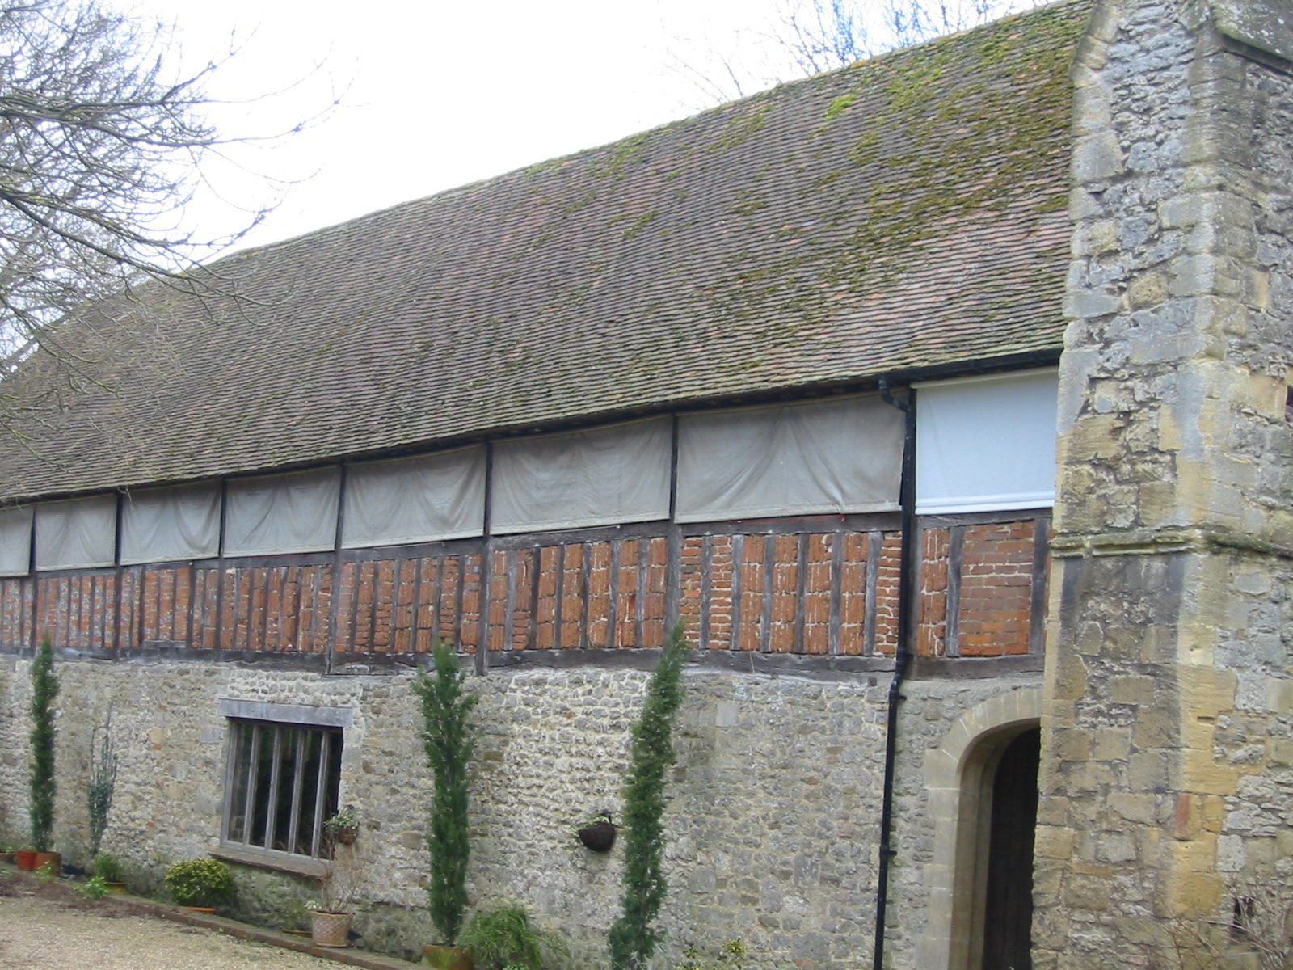
Saturday 18 June 2005
7.00pm
At the historic Abbey Buildings,
Abingdon

Pig Roast & Buffet

Entertainment provided by
Rascals Of Rhythm & Cavalleria Rustica

Tickets £25.00
Available from Josephine Hunt
Email jo@brucehuntassociates.co.uk
Lounge Suits
Carriages 11.30pm

